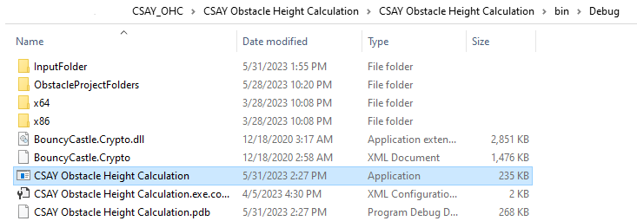

Software location address

Prepare input files here

Output files/folders appear here

Click to open application